**JSON API Data Load using TDV**

**Setup REST API Data Source**

**Step 1:**

**URL :** **https://api.covidtracking.com/v1/states/daily.json**

Open TDV Studion right click on shared Folder(Or you can create a new folder and store the Data source inside you folder).

Select New >> New Data Source

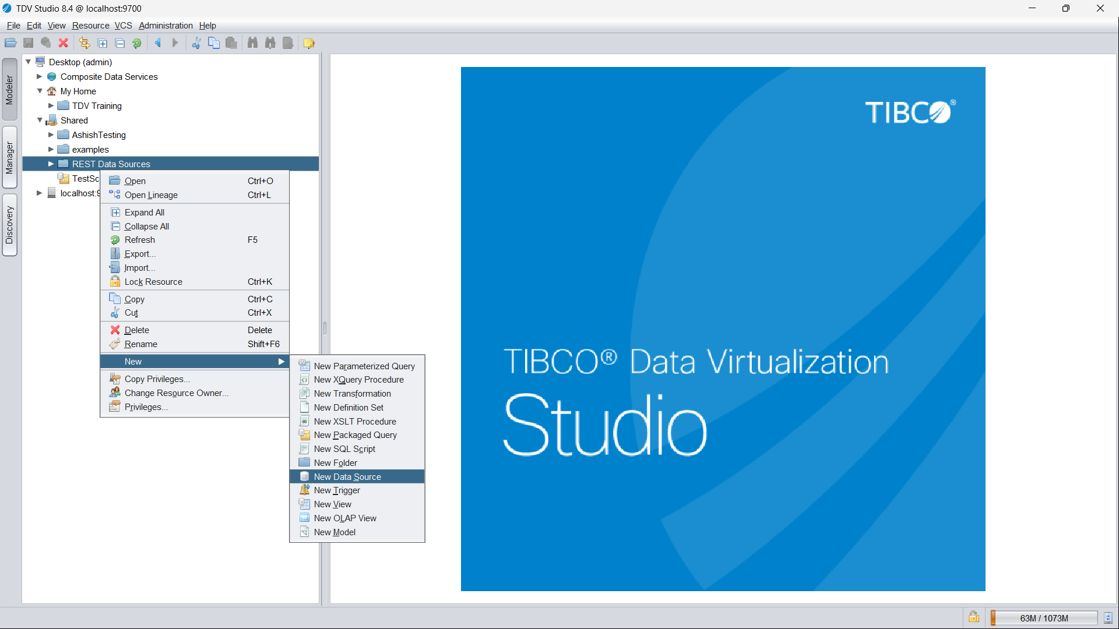

**Step 2:**

In the ‘New Physical Data Source”

**Step 3:**

Click “Next”,   
  
* Give the data source name
* Then we will provide Base URL (like, <https://api.covidtracking.com/v1>)
* Then check the JSON Format check box
* then provide Package name and Wrapper name.
* Then create One Operation by clicking + symbol, then provide operation URL (like, states/daily.json), then click on parse.  
    
  Graphical user interface, application

  Description automatically generated
* Then Input Header/Body Parameters by clicking + symbol.

* Then click on create.

* click on next, then finish it.  
    
  Graphical user interface

  Description automatically generated

* After the introspection is complete, you will be back to the "Physical Data source" configuration screen. In the "Header/Body Parameter" section, select the white "Design By Example" button which is located next to the “-“ sign which generates a popup.

then click on OK.

* Once you confirm everything, go ahead, and click on the "Save & Close" button.
* Expand the "Covid tracker" data source which we created above and select Operation and choose open. Execute the operation "Operation" and confirm the output. You can close this window after you see the output.

**Step 4:**

Then we can create new Transformations by right clicking shared folder.

Click On XSLT Transformation then click next

Give the transformation name (note: Transformation Name and datasource name both are same)

Expand the Data source the data source and cick on operation Then finish it.

**Step 5:**

##### Now you can expand "wrap" to see all of the objects from the REST service. Choose the objects you need and click on the link icon with an arrow to add to the output. This step is used to map the JSON objects to a relation table's columns.

**Step 6:**

##### Now save the changes and execute the transformation. Now you can see the data being returned from the REST web service in a tabular format.

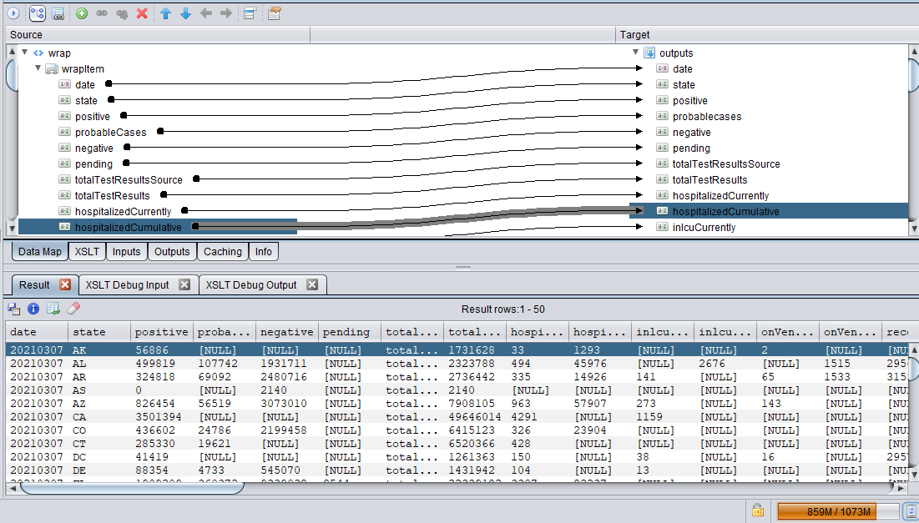

* Then publish it and add Composite Service, add Catalog and Add Schema as well.

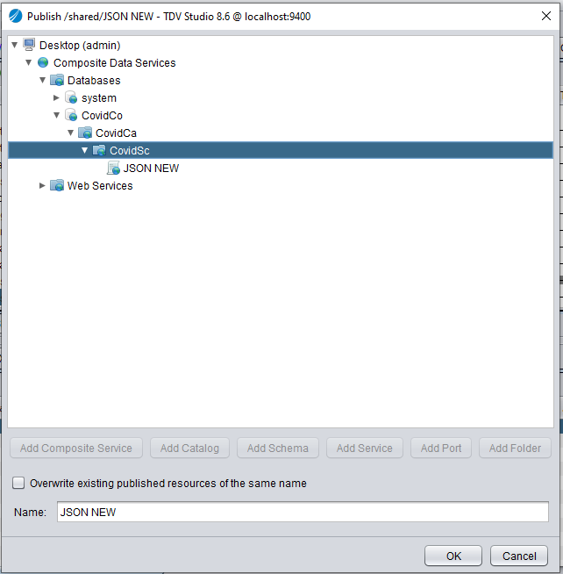

**Step 7:**

* Open the Spotfire configuration tool, then open the configuration tab then open Data source template and enable the TDV.

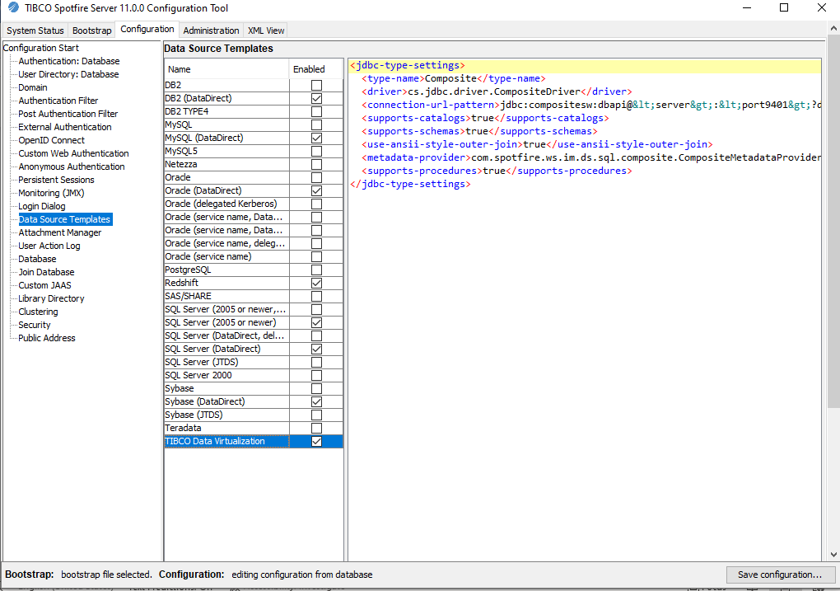

Save the configuration.

**Step 8:**

* Open the Information Designer on Spotfire.
* Set up the data source (connection URL - jdbc:compositesw:dbapi@localhost:9401?domain=composite&dataSource=covidcom)
* Give the TDV user name and password

**Step 9:**

* Go to start menu then select Procedure element and the go to Data source.

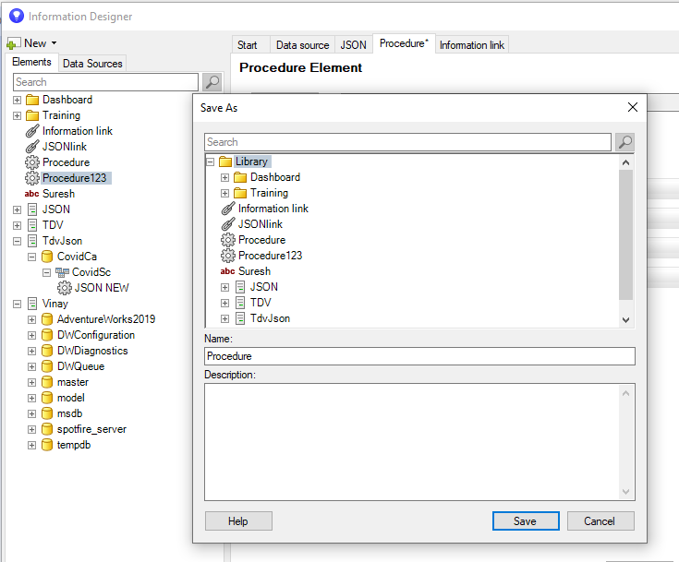

* Then go to start button and create Information link and add procedure.

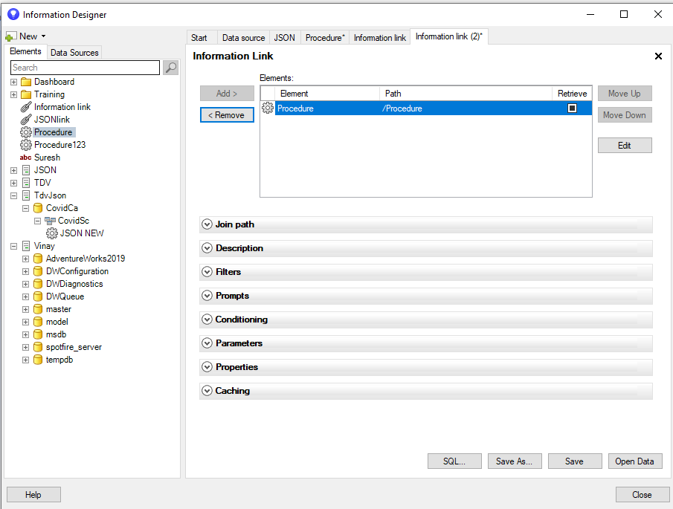

* Click on save then load the Information link on Spotfire Dashboard.

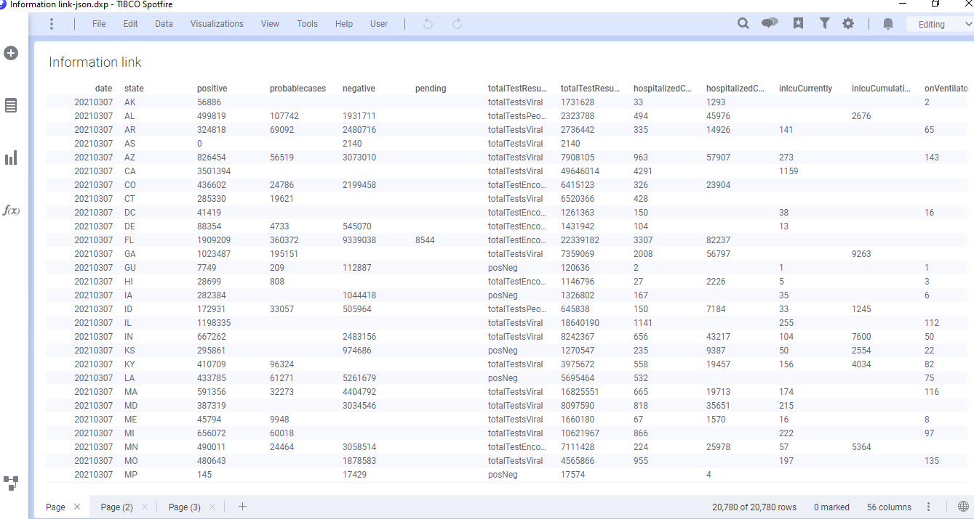  
Finally open the Spotfire Visualizations.